
课程设计报告书

学 院 华南理工大学
专 业 计算机科学与技术
组员 Lam Sung Foon Ryan林君海201969990099
Sara Sajid Undre映月201969990298
Vondrea Cassey Andoko孙秀凤201969990084
指导教师 李剑
课程编号 CST045C
课程学分 2.5
起始日期 30-05-2022

Home surveillance security

Abstract
In this report paper, we proposed our version of a Home Surveillance System. We trained a deep learning model using the Yolov5 architecture with a custom dataset that we manually labelled. The model was then used to perform object recognition on webcam live video feeds and send the pictures to the user via the Telegram API “Botfather”. We used python as our programming language and Jupyter notebook as our environment.

- Background of topic selection
Home security is important. It protects our home in various ways using sensors or cameras from theft or potential fires. It is no secret that arguably everyone wants to keep their home and family safe. After all, there are reportedly more safety accidents in families nowadays including short circuits, fire, gas leakage, illegal intrusion, and other forms of insecurities. However, having more sensible proof to the human eye may compromise our privacy. Therefore, it is quite a challenging task for security companies to balance security with someone’s personal life.

In the learning aspect, it is worth exploring methods of home security surveillance based on videos from home-installed cameras. Our implementation combines AI analysis and training algorithms to solve the problem of home AI safety monitoring.

This system realizes the following functions:
- Smoke and flame detection. If detected, it will send a message to the user as a form of alarm.
- Home break-ins. If a person is detected within a specified period of time, it will send a message to the user as a form of alarm.

- Scheme demonstration
To train the model, we used 3 datasets from Kaggle.com to create a custom dataset, giving us a total of 10,000 images, of which 3000 were neutral images.[1][2][3]. We manually labelled the images using MakeSense.AI and exported them in a Yolov5 format. We edited the coco.yaml file to fit our requirements and trained the model for 100 epochs using the default settings and the YOLOv5s.pt pretrained checkpoint. According to their GitHub page, this checkpoint is the fastest and lightest and since we do not have the computation power to train our model with heavier architectures for a longer period of time, this setting was the best option. The model finished training after 28 hours using a GTX 1050 as GPU.

The following figures are the graphs plotted by Weights & Biases (W&B) that are integrated into Yolov5 and show the results of the training:
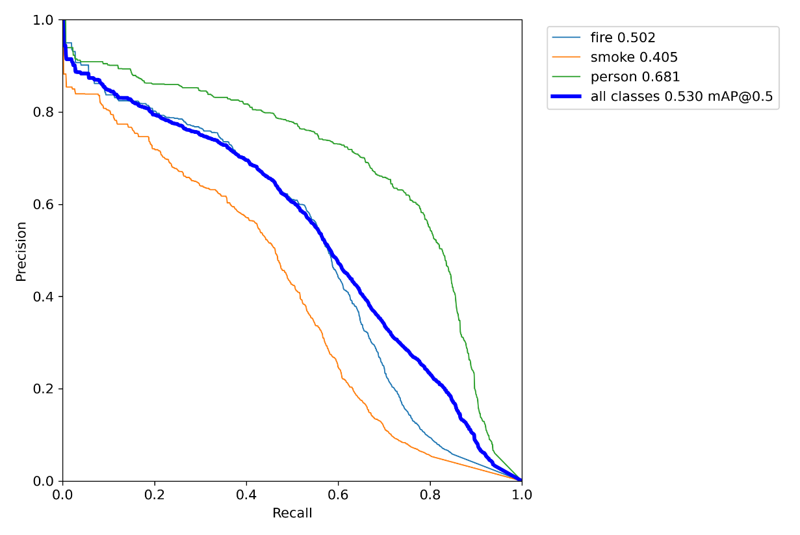
Figure 1. Precision Curve
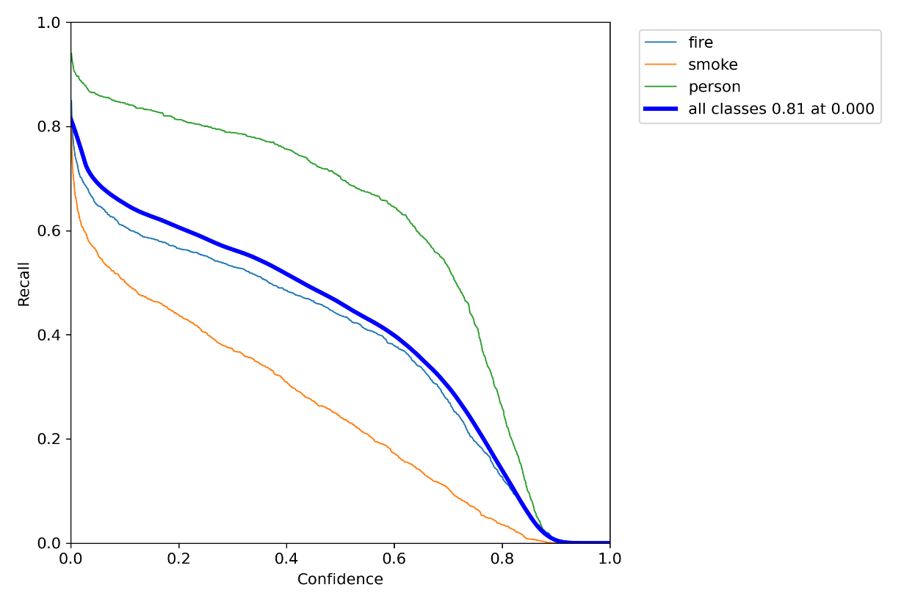
Figure 2. Recall Curve
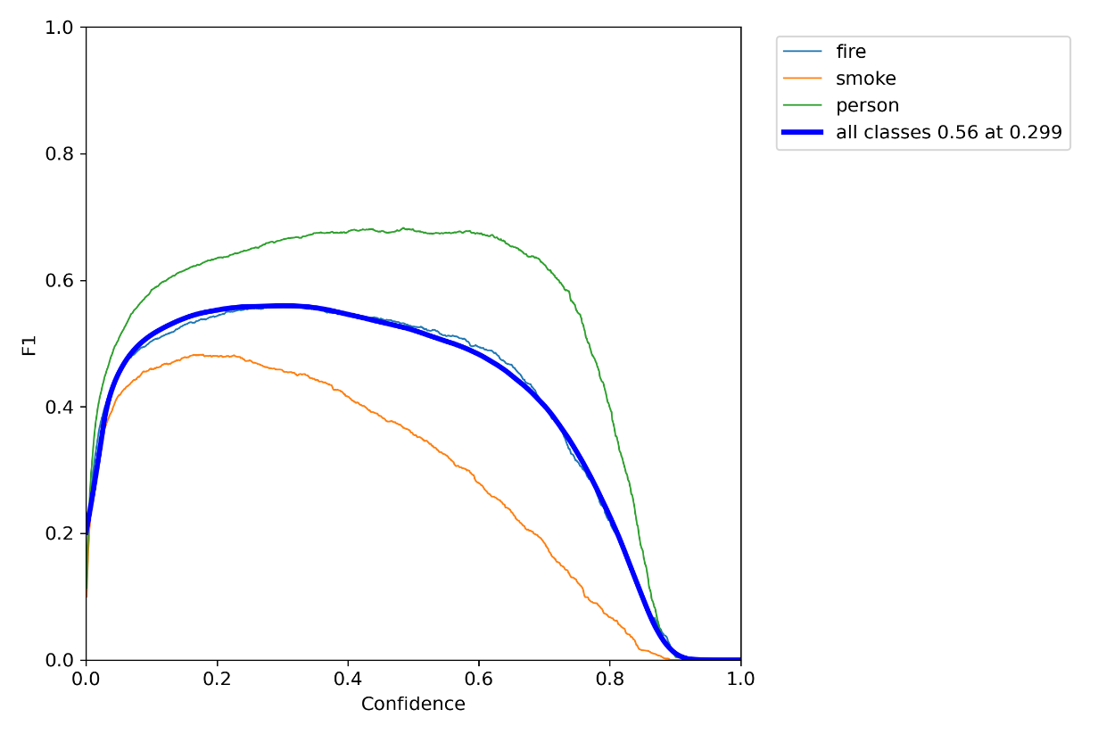
Figure 3. F1 Curve
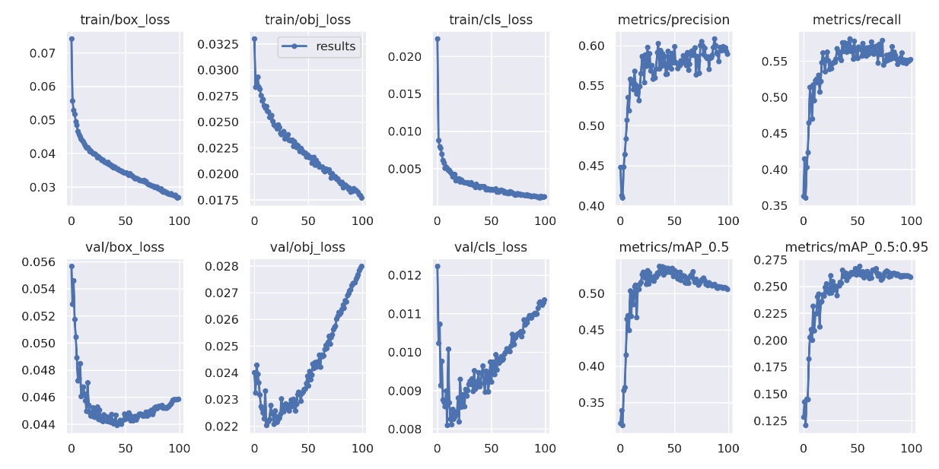
Figure 4 – Training and Validation Loss
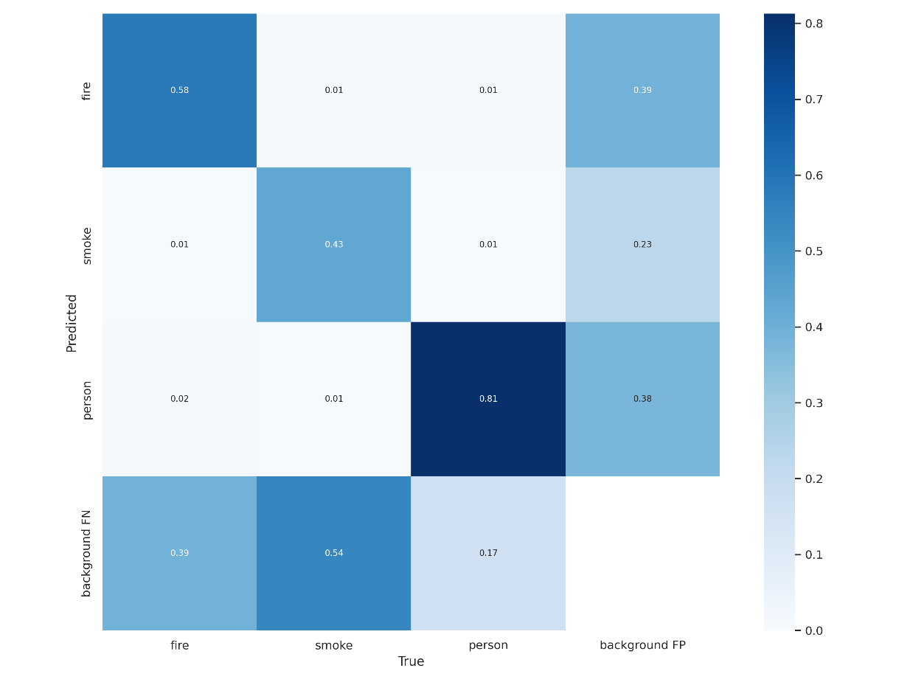
Figure 5. Confusion Matrix
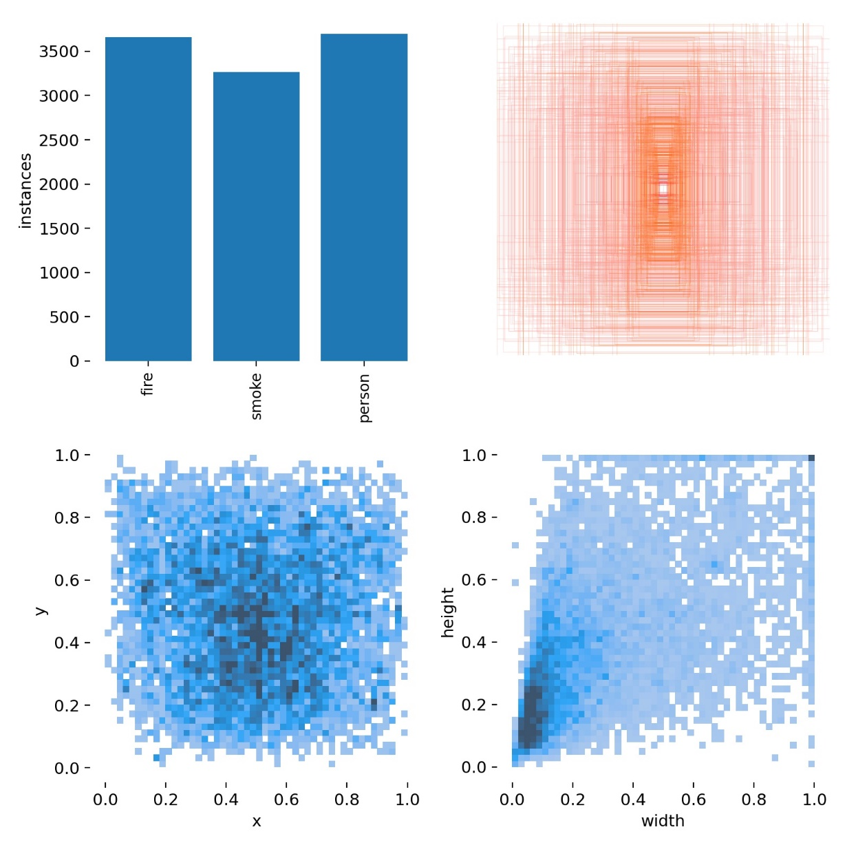
Figure 6. Labels
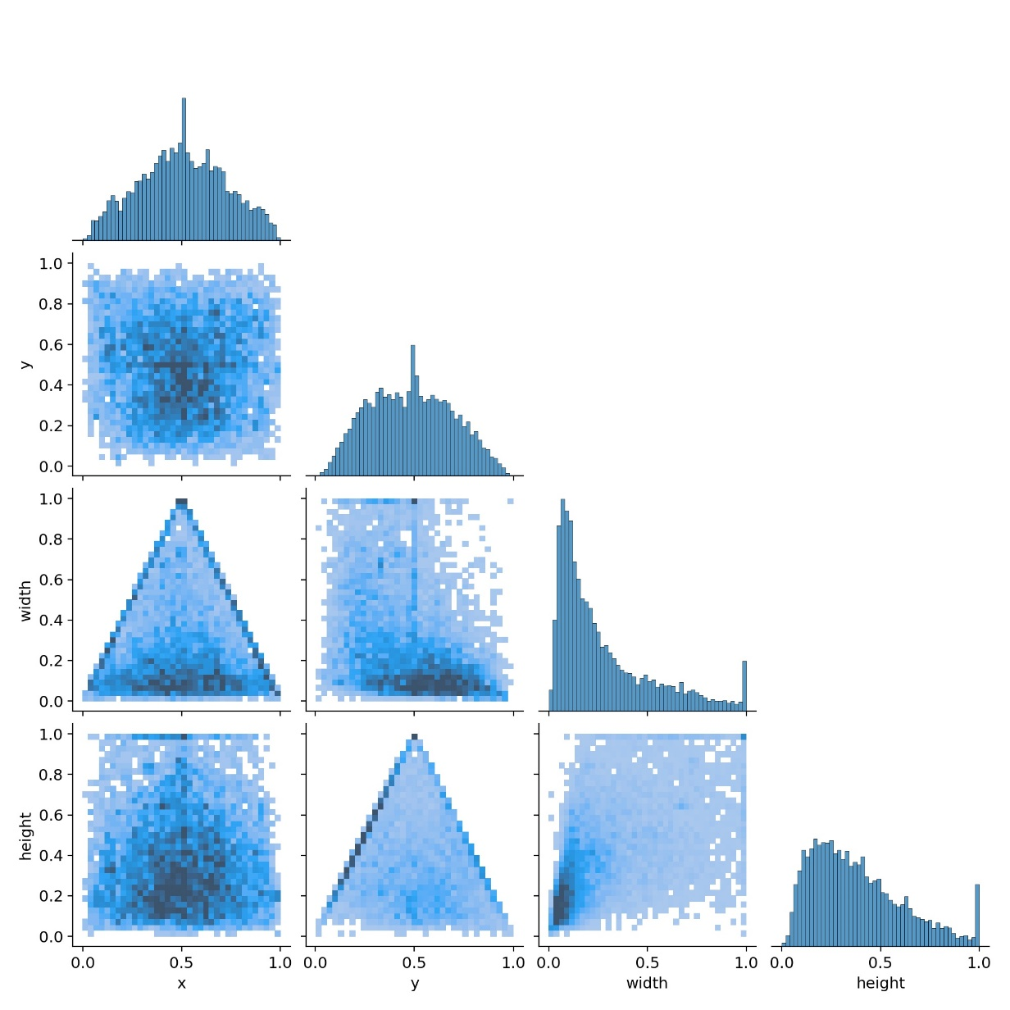
Figure 7. Labels Correlogram

We can observe that the training got an average accuracy of all classes of around 50%, peaking at 53%. As expected, the person class accuracy is higher than that of fire and smoke. The most common observation is that smoke seems more of a filter in front of the image and the system can also misclassify clouds as smoke. For fire, any bright spot can be detected as fire since the pictures taken from the dataset contain low-resolution images. Figure 8 shows the prediction of our model on a batch of pictures.

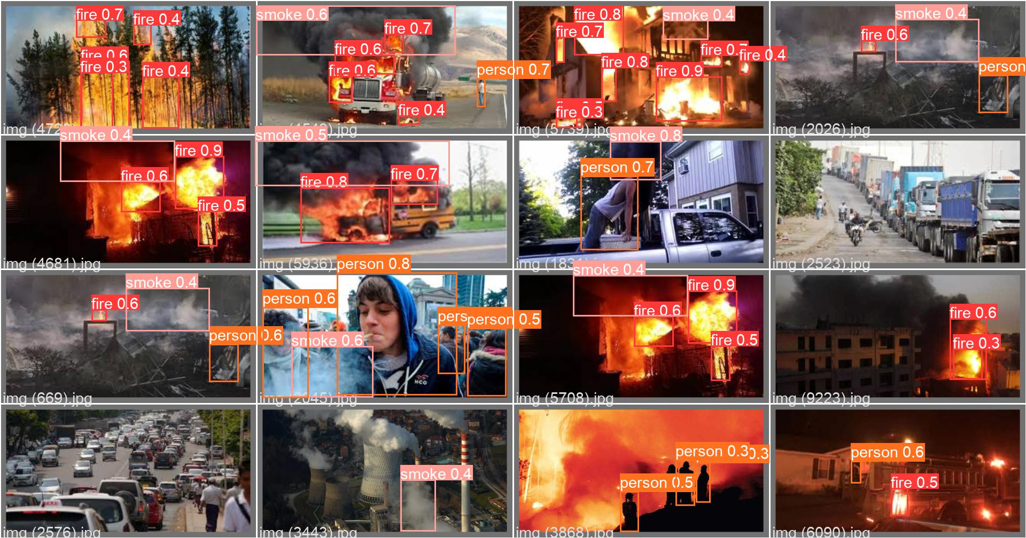
Figure 8. Val_batch1_predi

We observe that the model performs quite decently and it is all thanks to the Yolov5 architecture.

- Process discussion
Implementation
The implementation of the project was written in Jupyter Notebook, but it can also be deployed in a flask app as well. We first cloned the Yolov5 GitHub repository on our local device. We move our custom weights named “best.pt” to this path and created a folder named “detected”. Then, we created a .ipynb file that will act as our application. The program uses the “Botfather” Telegram API. The token was generated by the API after creating a new bot as shown in Figure 9 below.
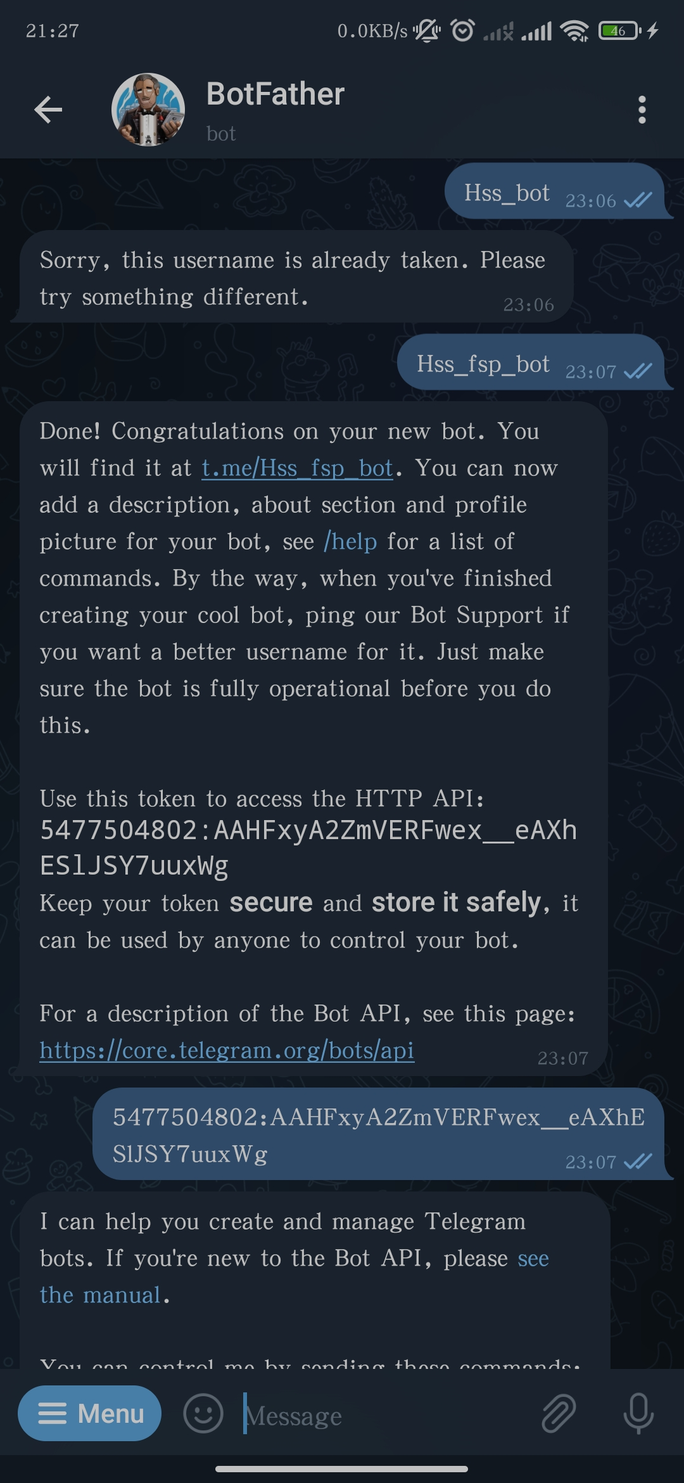
Figure 9. BotFather Token (Telegram App)

Afterwards, we got the receiver id by going to the link https://api.telegram.org/bot<TOKEN>/getUpdates and replacing the <TOKEN> string with the generated one. We use the bot functions to send a message to the user after initializing the bot to our token.

The camera is set to an integer 0 to specify the webcam (1 if there is a second webcam). The path is simply the path of the yolov5 environment that contains the best.pt weights (our trained model). We load the model using the function attempt_load(). Then, we use OpenCV to capture the images using our webcam and set the resolution to a reasonable 640 x 480 pixels (4:3 ratio). We defined 3 timestamps called now, today_10am, and today_3pm. We chose 10 am to 3 pm because according to www.adt.com this is the most common time for break-ins to occur. Rather than being guarded by night, most burglars choose the daytime to attempt a break-in, targeting homes when they believe no one will be present.

We open the camera using a standard while loop and perform inference by passing each frame into our model. We also took the freedom to stream the video capture so that we know what image is being fed into our model. The current time is also stamped on the video stream. The prediction is fed in the following conditions, described by pseudocode:

For x in predictions:
if class==fire or smoke and confidence score >0.10
Send picture and alert to user.

if class==person and between 10am and 3pm and confidence score >0.10
send picture and alert to user
We let the program “sleep” for 1 second because we found out that too much information is being passed in the system, which crashes the application. In addition, for each image sent, a copy is stored in the “detected” folder.

The bounding box is a simple implementation of the OpenCV function .rectangle() which draws - as the name suggests - a rectangle for a given image. Since we are passing the inference object “results” in a non_max_suppression() function, we can extract the xyxy coordinates of the detected object by accessing it like a list and calling the .item() function to get the value instead of the tensor object. We convert it into an integer and feed it as a parameter in the bounding box function. Finally, we write the label above the bounding box using the .puttext() method and passing str(model.names[class_]) since the class_ variable is an integer and we are accessing the names in the list.

- Result analysis

Test results
The following figures show the implementation of our projects in our own home using a connected webcam. Figure 10 shows the inference.

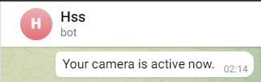

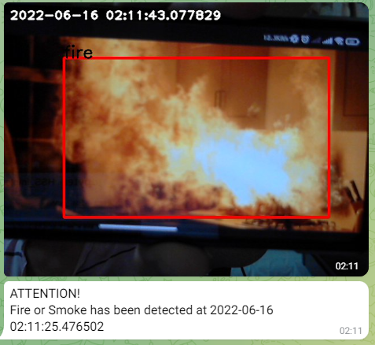

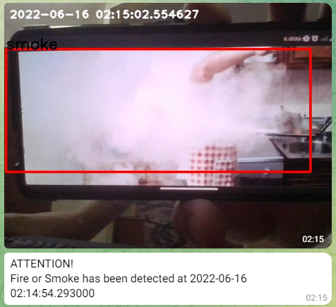

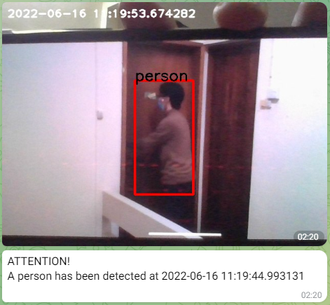
Figure 10. Inference
We can observe that, even if it is slow to detect, the home surveillance system is still fully operational and meets all the project requirements.

Challenges
As mentioned before, the model was not trained for long periods with the heavier architecture. Of course, it might not increase the accuracy of the model by much because of the current dataset used, but we can all agree that the hardware used was not sufficient.
The dataset labelling was also a heavy task since it took manual labelling from all three of us to complete in a week. We also perform the inference using a laptop camera. Therefore, we could not position the webcam as high as a typical surveillance camera. To solve this problem, we took pictures to mimic the 3 cases, namely: “fire, smoke, and person” detection. In addition, we can argue that it would perform slightly better when the camera would detect real-time objects instead of pictures from a phone.

- Curriculum Design Summary
This project gave us a better understanding of object recognition. The use of Yolov5 model also helped us improve on how to use repositories and predefined architectures more efficiently. We also discussed our implementation and methodologies on how to tackle the system. Without a doubt, this project will surely help us in the near future.

- References
- Glenn Jocher. Ultralytics, YOLOv5 2020. Available from: https://github.com/ultralytics/yolov5.

- Junfan WANG1, Yi CHEN1, Mingyu GAO, Zhenkang DONG. “Improved YOLOv5 network for real-time multi-scale traffic sign detection”. https://arxiv.org/ftp/arxiv/papers/2112/2112.08782.pdf

- Alexey Bochkovskiy, Chien-Yao Wang, Hong-Yuan Mark Liao. “YOLOv4: Optimal Speed and Accuracy of Object Detection”. arXiv:2004.10934v1 [cs.CV] 23 Apr 2020. https://arxiv.org/pdf/2004.10934v1.pdf

- Glenn Jocher. “YOLOv5 Documentation”. 18 May 2020 https://docs.ultralytics.com/

- Abhinu C G, Aswin P, Kiran Krishnan, Bonymol Baby, Dr. K S Angel Viji. “Multiple Object Tracking using Deep Learning with YOLO V5”. International Journal of Engineering Research & Technology (IJERT) Volume 9, Issue 13. ISSN: 2278-0181. NCREIS - 2021 Conference Proceedings. https://www.ijert.org/research/multiple-object-tracking-using-deep-learning-with-yolo-v5-IJERTCONV9IS13010.pdf

- Zhong-Qiu Zhao, Shou-tao Xu, and Xindong Wu. “Object Detection with Deep Learning: A Review”. IEEE Transactions on neural networks and learning systems for publication. arXiv:1807.05511v2 [cs.CV] 16 Apr 2019. https://arxiv.org/pdf/1807.05511.pdf

- Sandipan Chowdhury, Prabuddha Sinha. “Real Time Object Detection using Deep Learning: A Webcam Based Approach”. TECH VISTA Vol1, No.2, Feb 2019. https://techvistas.makautwb.ac.in/tech_vistas_papers.php?paper_id=CHOWDHURY-Real%20Time%20Object%20Detection%20using%20Deep%20Learning%20A%20webcam%20based%20Approach.pdf

- Amita, Meenakshi, Simran, Varsha & Ajay (2020). “Object Detection Using Machine Learning”. International Research Journal of Computer Science (IRJCS), Volume VII, 41-45. doi://10.26562/IRJCS.2020.APIS10084Editor Dr.A.Arul L.S, Chief Editor, IRJCS, AM Publications, India. April 2020. https://www.academia.edu/42912697/Object_Detection_Using_Machine_Learning

- Shrikant Jagannath Patro, Prof. Nisha V M. “Real Time Video Analytics for Object Detection and Face Identification using Deep Learning”. International Journal of Engineering Research & Technology (IJERT), ISSN: 2278-0181, Vol. 8 Issue 05, May-2019. https://www.ijert.org/research/real-time-video-analytics-for-object-detection-and-face-identification-using-deep-learning-IJERTV8IS050298.pdf

- Anish Aralikatti, Jayanth Appalla, S Kushal, G S Naveen, S Lokesh and B S Jayasri. “Real-time object detection and face recognition system to assist the visually impaired”. Journal of Physics: Conference Series, Ser. 1706 012149, Volume 1706, First International Conference on Advances in Physical Sciences and Materials 13-14 August 2020, Coimbatore, India. https://iopscience.iop.org/article/10.1088/1742-6596/1706/1/012149

- Rizky Parlika and Arista Pratama. “The Online Test application uses Telegram Bots Version 1.0”. Journal of Physics: Conference Series, Ser. 1569 022042, Volume 1569, International Conference on Science and Technology 2019 17-18 October 2019, Surabaya, Indonesia. https://iopscience.iop.org/article/10.1088/1742-6596/1569/2/022042/pdf

- Ariyono Setiawan, Yuyun Suprapto, I Gede Susrama, Mas Diyasa, Chilyatun Nisa, Maulana Idris, Feronika Nur Maghfiro, Yuri Setiawan, Dama Yanti Hilda. “Design and Development of Chatbot Using Dialog Flowin Surya Sembada PDAM Surabaya City”. International Joint Conference on Science and Engineering (IJCSE 2020), Advances in Engineering Research, volume 196. https://www.researchgate.net/publication/347408341_Design_and_Development_of_Chatbot_Using_Dialog_Flowin_Surya_Sembada_PDAM_Surabaya_City

- Paziak A., Diahyleva O., Leschenko O., & Yurzhenko A. (2020). “Development of intellectual chat-bot of the office of international cooperation”. Journal of Information Technologies in Education (ITE), (43), 17-27. https://doi.org/10.14308/ite000717

- Telegram Bot API. https://core.telegram.org/bots/api

- Leandro Toledo. “Python-telegram-bot Documentation”. Jun 09, 2022. https://buildmedia.readthedocs.org/media/pdf/python-telegram-bot/latest/python-telegram-bot.pdf
教  师  评  语 | 教师签名：  日期：
成
绩
评
定
备
注

